TITLE
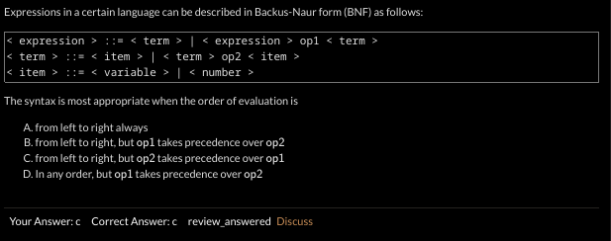
Study BNF, precedence and assositvity from grammar.

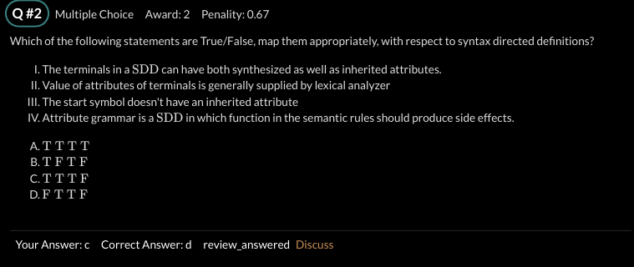
What does the symbol table store at differernt phase?

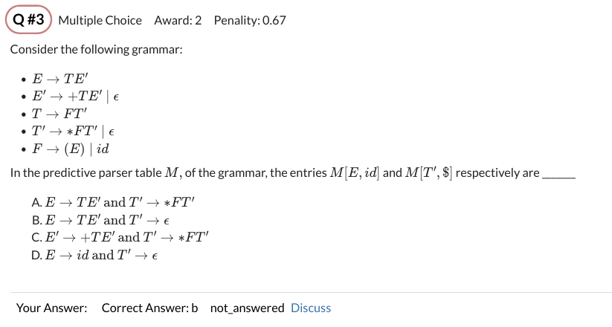
What is predective parser. Its table?
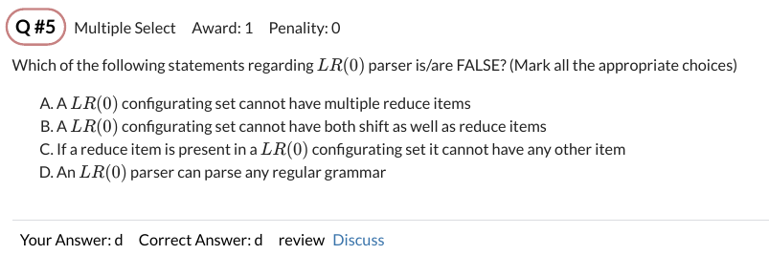
Grammers and comparions that differernt parsers can parse
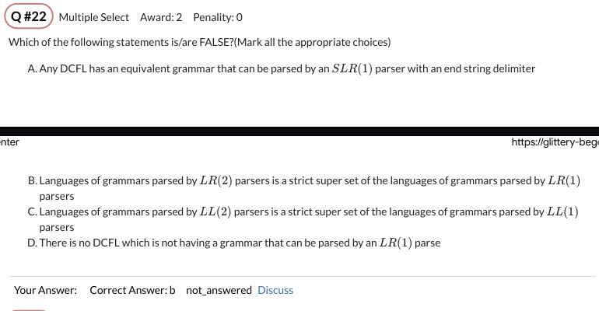

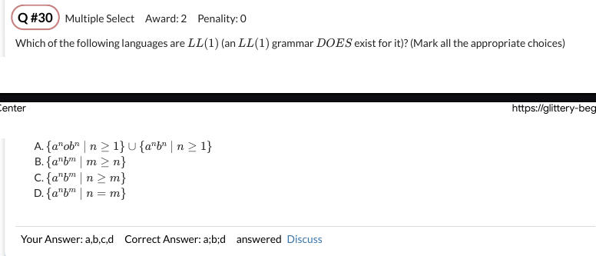
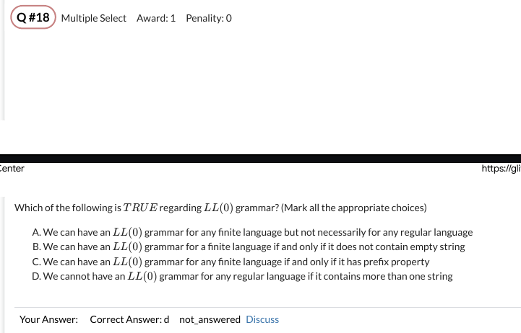

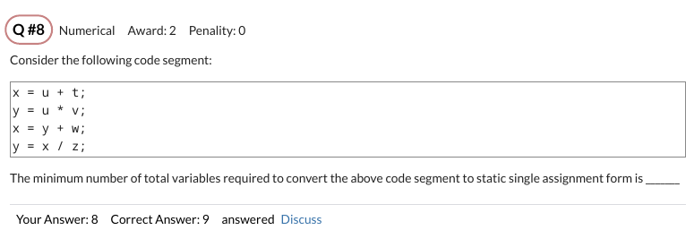

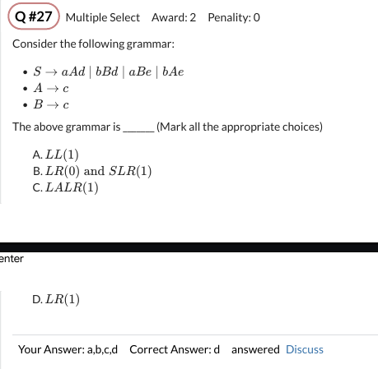

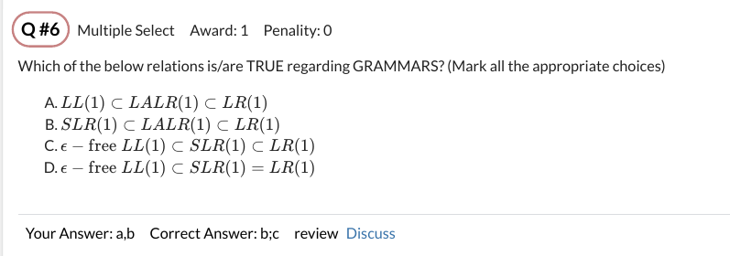
A. Strength reduction
B. Common sub-expression elimination
C. Constant folding
D. Constant propagation

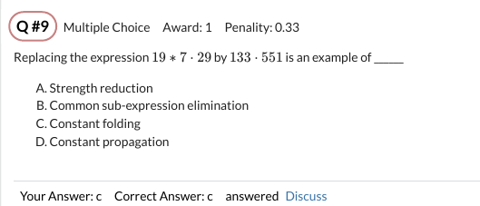
Attribute grammar, SDTs and ways of evaluating their values.

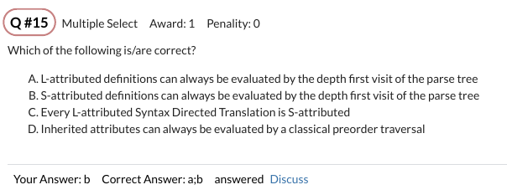

A,b are true.
D is not true. Note that in A,B we do preorder DFS. But D is not true because it has general version of inherted attrbiute which may not be done in one signle pass of DFS. But inherted attrbiution with restrction of those of L attriuted grammar can be calcuated with DFS by appropriately placing them the production.
Left recursive grammar
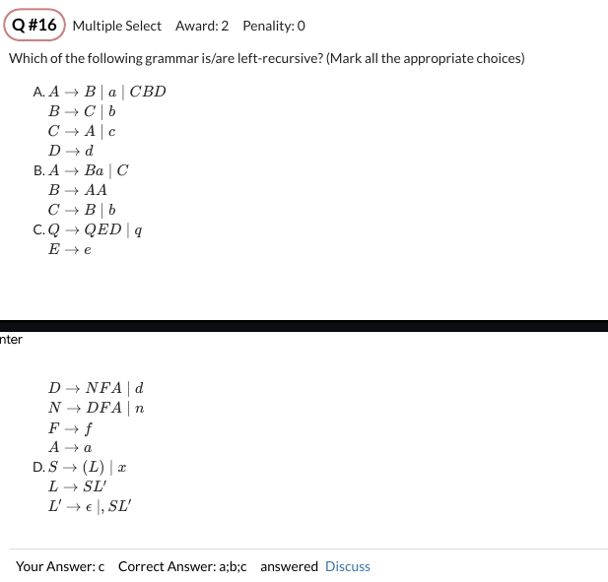

dynamic and static scoping
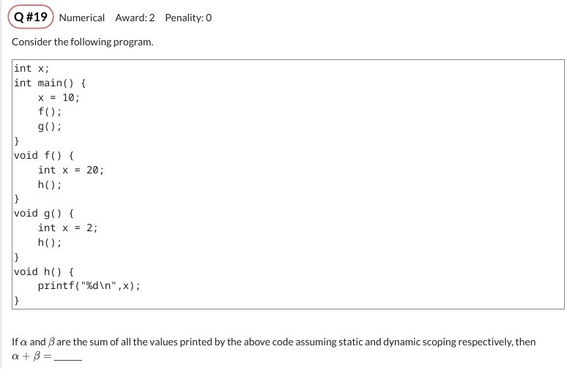

min regsiter needed

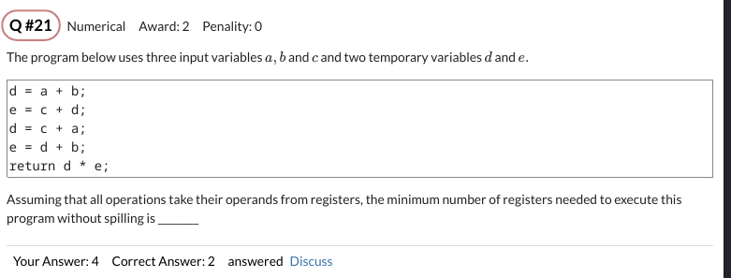

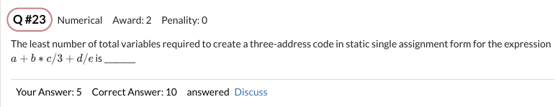

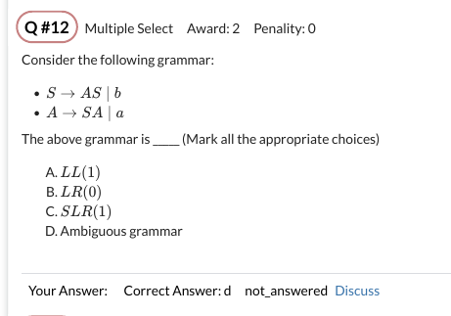

Test 1

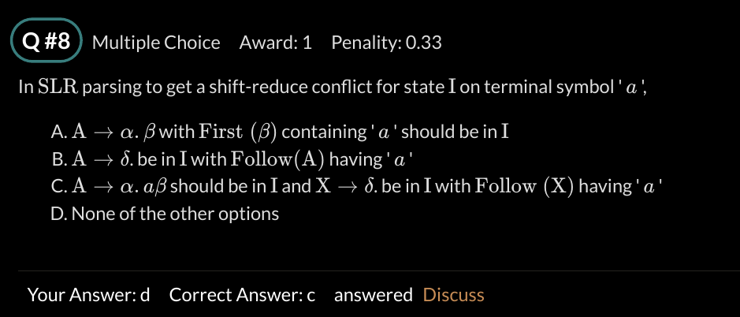
Remember the condtions of reduction, poping, shifting, expansion. How to construct table. First and follow, goto, action.

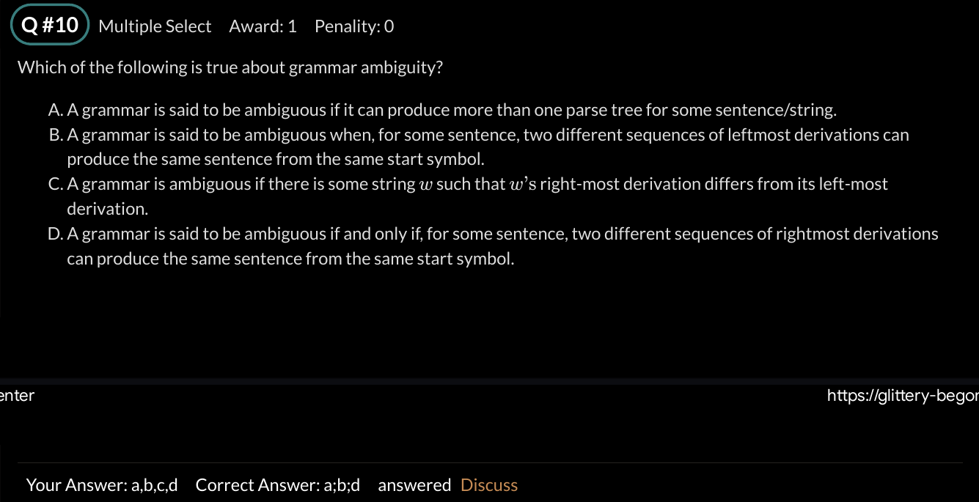
By right/left-most derivation we mean NOT parse tree but S->aSb….
Test 2
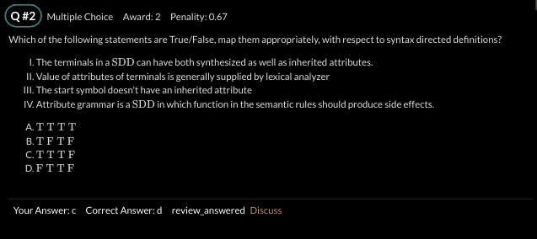
A terminal (leaf node) = token != lexeme.
It can only take values from below ie lexemes…..
not from above… infact no one dones it from above….
Everyone takes it from child or from siblings.
So being alone it can only take from child so only synthesied attributes possible for it.
Similiary for root only synthesied attrbiutes possible as it has no siblings too.

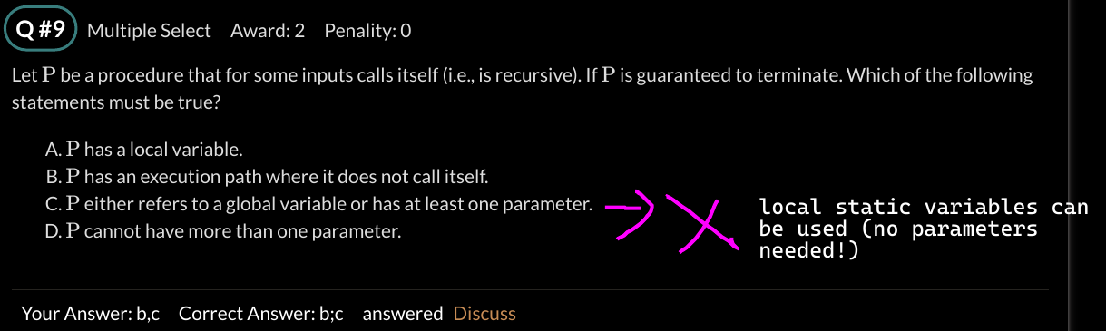
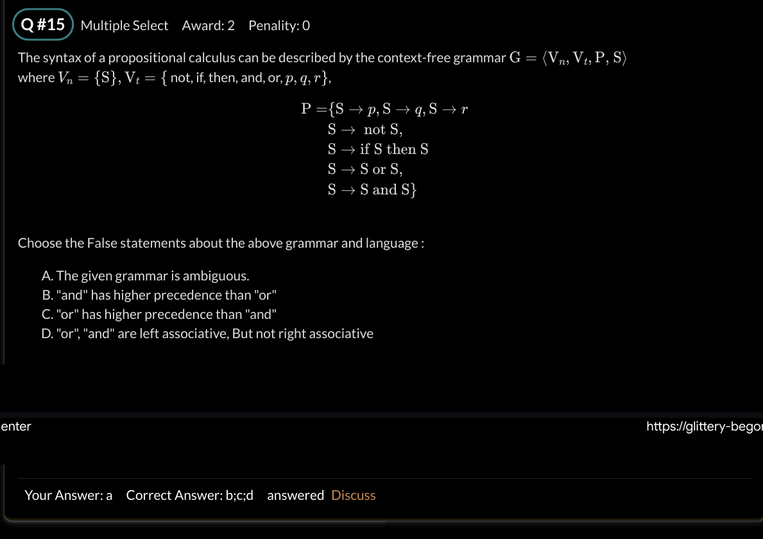
The grammar below has no fixed assostivity/precdence I expect it to be amigious.

Test 3
Learn how to calculate live/dead/kil/gen/accesible/not accesible sets
register allocation, ssa, 3ac why t1 not x, common expression analyis, revise…..,
sdd, sdt, ambiogus check, resolve?, pyq mistakes.

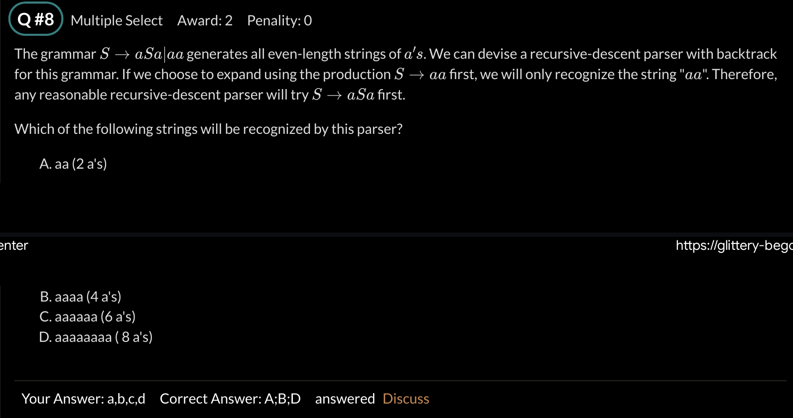

Test
infix, prefix, postfix calculation
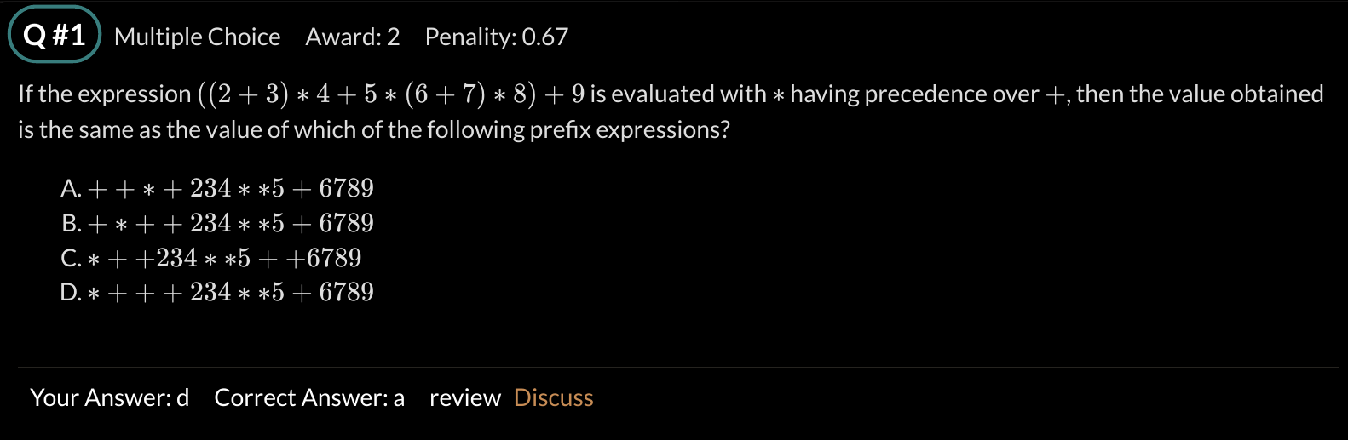

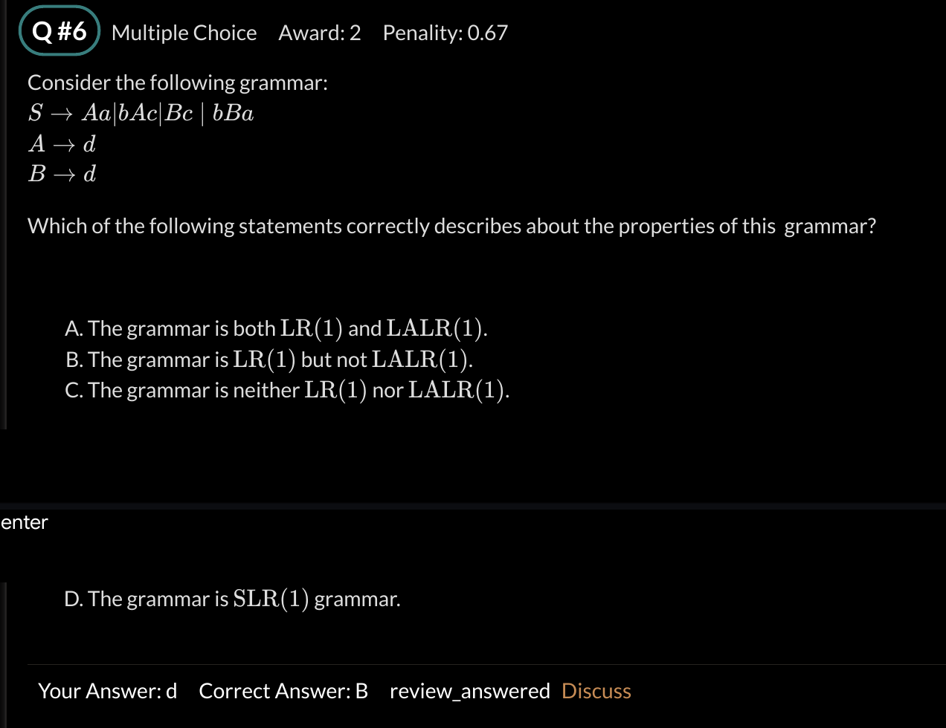
Write clearly, c write in cursive, C in print.

